# **Planning and Progress Report**

**Group:** C1.027  
**Repository:** [AirNav-Logistics](https://github.com/DP2-C1-027/AirNav-Logistics)**Date:** 02/15/2025

### **Group Members:**

1. **Garcia de Tejada Delgado, Jose**
   * Role: Developer
   * Email: jgd@acmeanalytics.com
2. **Peñaloza Friqui, Nora**
   * Role: Developer
   * Email: nora@acmeanalytics.com
3. **Niza Cobo, Manuel Jesús**
   * Role: Manager, Developer
   * Email: manuel@acmeanalytics.com
4. **Gomez Claraco, Nicolas**
   * Role: Developer
   * Email: nicolas@acmeanalytics.com
5. **Campos Diez, Lucia**
   * Role: Tester, Developer
   * Email: lucia@acmeanalytics.co

## **Table of Contents**

1. **Executive Summary**
2. **Revision Table**
3. **Introduction**
4. **Planning Chapter**
   * Tasks Performed
   * Estimated Budget
5. **Progress Chapter**
   * Progress Records
   * Conflicts and Resolution
   * Cost Comparison
6. **Conclusions**
7. **Bibliography**

## 

## 

## 

## 

## 

## 

## 

## 

## 

## 

## 

## 

## **Executive Summary**

This report aims to present the analysis, planning, and progress of the *AirNav-Logistics* project, which is being developed to create a comprehensive logistics management system for charter flights at airports. The document details the completed tasks, the progress of features, and the estimated and actual budget. It also covers the working methodology, conflicts encountered during development, and a comparison of the estimated and real costs. The purpose is to ensure the project is progressing according to plan, within the allocated time and budget.

## **Revision Table**

| **Revision** | **Date** | **Description** |
| --- | --- | --- |
| 1 | 15/02/2025 | Creation of the analysis, planning, and progress report. |

## **Introduction**

This report presents the analysis, planning, and progress made in the AirNav-Logistics project developed by group C1.027. The objective of this project is to create a system that helps airports manage resources for charter flights. The report is divided into two chapters: planning and progress, which include a detailed description of the assigned tasks, their execution, associated costs, and managed conflicts.

The structure of the report includes a breakdown of the tasks performed by Nora Peñaloza Friqui, an analysis of the costs involved, and a summary of the conflicts resolved during the project's development.

## 

## 

## 

## 

## 

## 

## 

## 

## 

## 

## 

## 

## **Planning Chapter**

### **Tasks Performed:**

**→Individual requirements:**

**Task 1: Modify the anonymous menu**

* **Description:** The anonymous menu was modified to display an option that redirects the browser to the homepage of a favorite website, with the title formatted as: “〈id-number〉: 〈surname〉, 〈name〉”.
* **Assigned to:** Nora Peñaloza (developer)
* **Planned Time:** 30 minutes
* **Actual Time:** 15 minutes

**Task 2: Provide a link to the GitHub planning dashboard**

* **Description:** A link was provided to the planning dashboard for reviewing the task statuses and project schedule.
* **Assigned to:** Nora Peñaloza (developer)
* **Planned Time:** 30 minutes
* **Actual Time:** 10 minutes

**Task 3: Planning and Progress Report**

* **Description**: Created the planning and progress report with all the required details.
* **Planned Time**: 3 hours
* **Actual Time**: 4 hours

**Task 4: Analysis Report**

* **Description**: Produced the analysis report with the corresponding logs.
* **Planned Time**: 3 hours
* **Actual Time**: 3 hours

**Task 5: Set up the workspace**

* **Description**: Configured the workspace for the project.
* **Planned Time**: 1.5 hours
* **Actual Time**: 5 hours

**Task 6: Attend classes**

* **Description**: Attended 6 classes, each lasting 1.5 hours.
* **Planned Time**: 9 hours
* **Actual Time:** 9 hours

**→Group requirements:**

**Task 7: Edit text files**

* **Description:** Edited the changelog, contributors, license, and readme files of the repository to keep documentation up-to-date.
* **Assigned to:** Nora Peñaloza (developer)
* **Planned Time:** 2 hours
* **Actual Time:** 1.5 hours

**Task 8: Report on WIS Testing**

* **Description**: Created a report on the tests conducted on the WIS system.
* **Planned Time**: 2 hours
* **Actual Time**: 2 hours

**Task 7: Meeting1**

* **Description**: Configured the workspace for the project.
* **Planned Time**: 1.5 hours
* **Actual Time**: 5 hours

**Task 8: Meeting 2**

* **Description**: Attended 6 classes, each lasting 1.5 hours.
* **Planned Time**: 9 hours
* **Actual Time:** 9 hours

**Screenshots of Development Stages**

**1. Initial Task Definition in the "To Do" Lane**

Screenshot showcasing the tasks that were initially defined in the "To Do" lane. All tasks were outlined and assigned at the beginning.

(Group Task)

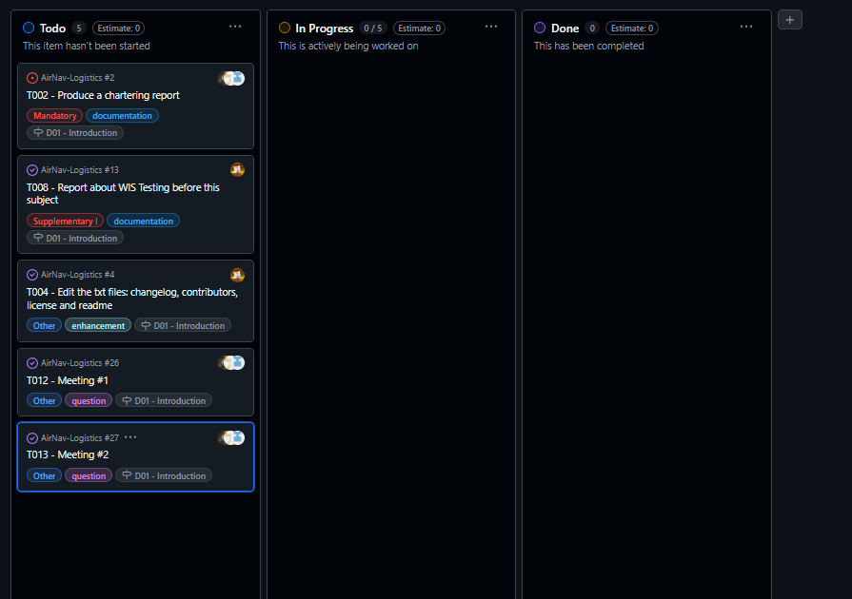

#### **2. Midway Through the Delivery: All Types of Tasks in Various Lanes**

Screenshot of the task board showing all kinds of tasks in various lanes, including regular tasks, quality-assurance tasks, and revisions as required.

(Group Task)

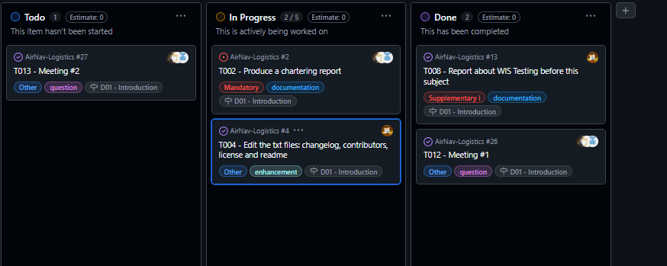

#### **3. Final Task Completion in the "Done" Lane**

Screenshot of all completed tasks in the "Done" lane, indicating the successful completion of all deliverables.

(Group Task)

These screenshots illustrate the adherence to the working methodology defined in “L01/S03 - Working Together,” ensuring transparency and collaborative task management.

### **Estimated Budget**

**Estimated hours by role:**

* **Modify the Anonymous Menu**: 0.5 hours
* **Provide a Link to the GitHub Planning Dashboard**: 0.5 hours
* **Planning and Progress Report**: 3 hours
* **Analysis Report**: 3 hours
* **Edit Text Files (Changelog, Contributors, License, Readme)**: 1.5 hours
* **Report on WIS Testing**: 2 hours
  + **Total Estimated Hours for Nora**: 10.5 hours

**Cost per role:**

**Developer (Nora Peñaloza): €20/hour**

**10.5 hours x €20 = €210**

**Amortization:**

* The amortization has been calculated using a linear method over three years, with an annual cost of €20.00 for the infrastructure used.

**Total Estimated Cost:**

* **Developer: €210**
* **Amortization: €20.00**
* **Total Estimated: €230.00**

**Progress Chapter**

#### **Progress Records**

| **Team Member** | **Performance Indicators** | **Value** | **Description** |
| --- | --- | --- | --- |
| Nora Peñaloza | Task Completion | Good | All tasks completed on time and within the estimated time. |

### **Reward/Admonishment**

### No formal reward was applied, but Nora's efficient completion of tasks is noted as a positive contribution to the team’s success.

### **Conflicts and Resolution**

No major conflicts arose during development. The team members worked collaboratively to address any technical challenges independently.

#### **Cost Comparison**

| **Cost Component** | **Estimated Cost** | **Real Cost** |
| --- | --- | --- |
| **Developer (Nora Peñaloza)** | **€210** | **€210** |
| **Amortization** | **€20.00** | **€20.00** |
| **Total Cost** | **€230.00** | **€230.00** |

### The real cost aligns with the estimated cost, confirming that the project has remained on budget.

### 

## 

## **Conclusions**

The *AirNav-Logistics* project is progressing as planned. The assigned tasks have been completed within the established timelines and budget. There were no major deviations from the estimated costs, and Nora’s performance has been instrumental in ensuring the success of the project. The work has been carried out efficiently, and the resources used have been sufficient to meet the project’s requirements.

## **Bibliography**

Intentionally blank.